**Freedom of Information Act (FOIA) Policy**

**Colona District Public Library**

**ABOUT THE COLONA DISTRICT PUBLIC LIBRARY (PUBLIC BODY)**

The Colona District Public Library serves a community of over 6,621 residents, as well as reciprocal borrowers from the PrairieCat System, along with any and all visitors who pass through the library’s doors.

We are required to report to and be answerable to: Illinois State Library, Springfield, Illinois. Its members are: State Librarian Alexi Giannoulias, Director of the State Library, and various other staff.

**OUR MISSION**

The Colona District Public Library provides services and high interest materials in a variety of formats. This enables the district residents to obtain information to meet their personal and educational needs. Special emphasis is placed on stimulating young readers to use and enjoy the library and to provide services for students of all levels.

**COLONA DISTRICT PUBLIC LIBRARY’S WEBSITE**

<https://www.colonalibrary.com/>

**GENERAL FUND OPERATING BUDGET**

The fiscal year budget for 2024-2025 is $324,987. Budget documents are available on the library’s website as well as in person at the library’s administration office. Funding sources are property and personal property replacement taxes, state and federal grants, fines, charges, and donations. Tax levies are:

* Corporate purposes (for general operating expenditures)
* Social Security (provides for employee’s FICA costs and related expenses)
* Audit (for annual audit and related expenses)
* Maintenance (for maintaining the building)
* Working Cash (no longer levied)
* Tort Liability (for insurance premiums, risk management, attorney’s fees and related expenses, unemployment and worker’s compensation insurance)
* Illinois Municipal Retirement Fund

**COLONA DISTRICT PUBLIC LIBRARY OFFICE**

The administration office of the Colona District Public Library is located at 911 1st Street Colona, IL 61241. The library only has one branch. The library is opened Monday-Friday 10am-8pm and Saturday 10am-3pm.

**COLONA DISTRICT PUBLIC LIBRARY STAFF**

When fully staffed, the library employs 3 full time employees and 5 part time employees. Library departments and their staff are included in the organizational chart below.

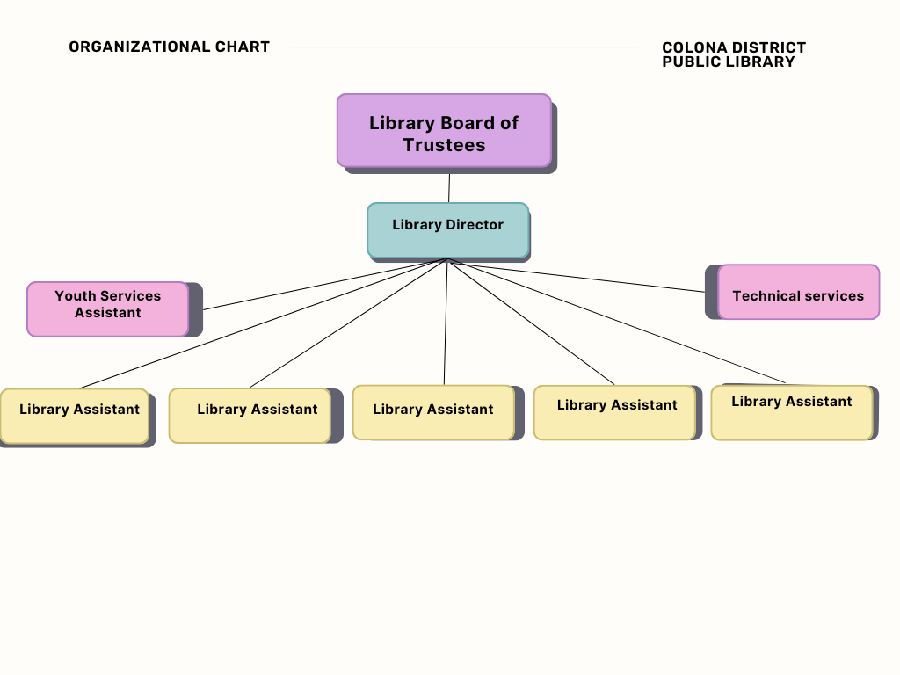

**COLONA DISTRICT PUBLIC LIBRARY TRUSTEES**

Colona District Public Library is governed by an elected, unpaid, seven-member Board of Library Trustees. Current Board Members are:

President: Steven Hughes

Vice-President: Kathryn White

Treasurer: Sherri Clark

Secretary: Charlene Massarolo

Trustee: Susan Koska

Trustee: Traci Rieger

Trustee: Mary Rizzolo

Open board meetings are held on the second Tuesday for the months of August, October, November, January, March, May, and June at 6:30pm in the multiple purpose room at the Colona District Public Library. Trustees may be contacted at contact@colonalibrary.com or at the library’s general mailing address.

**FREEDOM OF INFORMATION ACT**

The Colona District Public Library adheres to the Freedom of Information Act, 5 ILCS 140/1 et. Seq., which is the principal Illinois statute governing the inspection of public records. The Act requires that public bodies make available for inspection or copying all public records to any person.

The requester shall provide the following information in a request for public library: 1) requester’s full name, address, email address or telephone number; 2) a description of the public records sought, being as specific as possible; 3) a statement as to whether the request is for a commercial purpose as defined in the Act.

**COLONA DISTICT PUBLIC LIBRARY FOIA OFFICERS**

Library Director: April Hoste [director@colonalibrary.com](mailto:director@colonalibrary.com)

Library Assistant: Roger Decker

**FILING A FOIA REQUEST**

A request for records must be made in writing and can be submitted to the attention of the FOIA officer in the following ways:

* **Mail**

Attn: FOIA Officer

911 1st Street

Colona, IL 61241

* **Email**

[director@colonalibrary.com](mailto:foia@fppl.org)

* **Personal delivery**

Monday – Friday 10am to 4pm at the Colona District Public Library

**FREEDOM OF INFORMATION ACT REQUEST FEES**

Digital copies shareable via electronic means are provided free of charge.

The charge for copies of the records will be as follows:

1. First 50 pages black and white, letter size: Free
2. 15 cents per page for black and white, letter size, after 50 pages
3. 50 cents per page for color or oversized copies or electronic media
4. Reproduction saved to other media: actual cost of the recording media (flash drive, etc.) to which the information will be saved
5. There is a $1.00 charge for each certification of records.

**RESPONSES TO REQUESTS FOR RECORDS**

Responses to commercial requests can be expected within 21 business days of the receipt of a written request. If an extension is required, a FOIA officer from the library will reach out to the requestor.

Responses for non-commercial requests can be expected within 5 business days of the receipt of a written request. If an extension is required, a FOIA officer from the library will reach out to the requestor.

**PROCEDURE FOR APPEALING A DENIAL**

If your request for information is denied, or denied in part, you have the right to have your request reviewed by the Public Access Counselor (PAC) at the Office of the Illinois Attorney General. 5 ILCS 140/9.5(a). You can file your Request for Review with the PAC by writing to:

*Leah Bartelt, Public Access Counselor*

*Office of the Attorney General*

*500 S. 2nd Street*

*Springfield, Illinois 62701*

*Phone: (877) 299-3642*

*Fax: (217) 782-1396*

*E-mail:* [*public.access@ilag.gov*](mailto:public.access@ilag.gov)

You also have the right to seek judicial review of your denial by filing a lawsuit in the State circuit court. 5 ILCS 140/11. If you choose to file a Request for Review with the PAC, you must do so within 60 calendar days of the date of this denial letter. 5 ILCS 140/9.5(a). Please note that you must include a copy of your original FOIA request and the denial letter when filing a Request for Review with the PAC.

**RECORDS IMMEDIATELY AVAILABLE UPON REQUEST**

The records listed below are available immediately via our website or upon request. These records are under the control of the public body. The Colona District Public Library adheres to the guidance for retaining business records set out by the Local Records Commission through the State of Illinois.

https://www.colonalibrary.com/other-library-policies

|  |  |
| --- | --- |
| **Records** | **Time Frame** |
| Annual Financial Report to Illinois | Current |
| Annual Report to the Illinois State Library | Current |
| Appropriation -Budget | Current |
| Annual Audit Report | Most Recent |
| FOIA | Current Fiscal Year |
| Levy | Current |
| Library Policies | Current |
| Meeting Agenda | January 2021 to present |
| Meeting Minutes | January 2021 to present |
| Mission Statement | Current |
| Monthly Financial Statements | Current Fiscal Year |
| Ordinances and Resolutions of the Board | Current Fiscal Year |
| Organizational Chart | Current |
| Strategic Plan | Current |
| Trustee Information | Current |

Adopted: March 9, 2010 Updated: August 2018 Updated Budget March 2025

Updated officers: May 2010 Updated/Approved: March 2019

Updated: March 2013 Updated: Sep 1, 2021

Updated officers: May 2015 Reviewed March 2022 SH

Updated budget: Sep 8, 2015 Updated Budget Nov 2023

Updated budget: March 2016 Format Change and updated Jun 2024